Mary, Mother of the Church Saintfield
Open Sun. Tues. Wed. Thurs.10 am – 4 pm
Mon. Fri. Sat. 10 am – 8 pm
MASS
Saturday 6:30 pm
Sunday 11:00 am
Monday, Friday 7:30 pm
Adoration of the Blessed Sacrament
Monday 7:00 pm

St Joseph’s Church, Carrickmannon
Open Sat & Sun 10:00 am – 2:00 pm
MASS
Sunday 9:00 am
Tuesday 10:00 am

CONFESSIONS
Before Vigil Mass on Saturday

ALTAR SOCIETY
Saintfield – Group 1
Carrickmannon – Team 4

READERS
31 Jan/1 Feb 2026
Vigil: Mary Davies
9 am: Anna Murray
11 am: Siobhan McGowan

EUCHARISTIC MINISTERS
31 Jan/1 Feb 2026
Vigil: Gerard Mullan, Eileen Murray
9 am: Margaret Bennett
11 am: Audrey Mullan
George Kerr, Damian Mulholland

St Vincent de Paul Society
Telephone:07521463667
Email: stmochai.saintfield@svpni.co.uk

Follow Me
and I will make you
Fishers of men

Please remember in your prayers ++ Recently deceased: John Heaney, James Byrne, Franz Eigel and Kevin Holland.
Anniversaries: Julia Okon, Anne Smith, Randal Ferris, Patricia McMullan, Mary McCaffrey, Gerald Adair, Maggie Creighton, John Murray, John Heaney, Phyllis McLoughlin, Andrew Ward, Seamus Kelly and all the Holy Souls in Purgatory.

The Week of Prayer for Christian Unity ends today. Killinchy Churches Together warmly invite our congregation to the Annual Ecumenical Service this evening at 7:00 pm in St Mary’s Church of Ireland, Kilmood.
Theme: One hope, one calling' - comes from St Paul's letter to the Ephesians: "There is one body and one Spirit, just as you were called to the one hope of your calling" (Eph. 4:4).

FEAST DAYS
Monday: St Timothy & Titus
Tuesday: St Angela Merici
Wednesday: St Thomas Aquinas
Friday: St Aidan
Saturday: St John Bosco


Every Sunday at 11am Mass

At today’s Mass, we hear about people who lived in darkness seeing a great light. This is the light that Jesus brings into the world. It is the light of God’s love for each one of us. Jesus asks us to care for one another. By doing this we can help the light of Jesus to shine in the world. What will you do to share the light of God’s love for us all this week?

Our prayer for this week:
God of hope, share your light with all your children as we work together to help those among us who are in need. Amen.

Worksheets and the Kids Bulletin to support this week’s Gospel are available in both churches. Pick up copies for your children/grandchildren.

Medjugorje Pilgrimage 29th July-5th August 2026 - an opportunity to experience the Peace of Medjugorje and the absolute Joy of our faith with the Mladifest Youth Festival. 7 nights £755 pps (£705 with January discount). Contact Éadaoin 07706288095.

Weekly Collection 18 Jan £1185


Monday Social Club
Next meeting
2nd February 2026
12:30 – 2 pm

Crois Dharach CLG Club
Lotto Numbers: 2 3 6 16
No Jackpot winner. Consolation prizes:
Pat McMahon, John McMullan and Declan Murray. New Jackpot £8000. Tickets available on Klubfunder page, Oaks Bar, Chestnut Bar, Vivo Shop, Dufferin Bar, International & Central Bars Killyleagh.

Screening of the 2025 Oscar-winning documentary No Other Land - a moving collaboration between Palestinian and Israeli filmmakers. Thursday 29th January, 7.00-9.30pm at the Belfast Jesuit Centre. No registration needed, small donation suggested.

This year, The St Brigid’s Day Lecture will be given by Fr Tom Layden, S.J. Fr Layden is a Jesuit priest, living and working in Belfast. The theme of his lecture, “The Nicene Creed: A foundation for Ecumenism”, is based on Pope Leo XV1’s address at Nicaea. Venue: St Brigid’s Parish Centre, Derryvolgie Avenue, Belfast BT9 6FP, on Sunday 8th February, at 4.00pm.
All are welcome.

CHURCH CANDLES SPONSORSHIP
Booklets are now available in both churches if you wish to sponsor the sanctuary candle on any week from 1st February 2026 to 31st January 2027 in memory of family living and deceased.
I will make you fishers of men. Jesus was speaking to fishermen, using the language they understood. Their lives changed on the spot. He called them where they were and as they were, in order to make them sharers in his mission. “Immediately they left their nets and followed him”. Why immediately? Simply because they felt drawn. They did not hurry off because they had received an order, but because they were drawn by love. To follow Jesus, mere good works are not enough; we have to listen daily to his call. He, who alone knows us and who loves us fully, leads us to put out into the deep of life. Just as he did with the disciples who heard him.
Young people embrace your vocation as "pilgrims of hope," offering your lives generously in service to others and as a response to God's love. Every vocation in the church -- to ordained ministry, consecrated life or life as a layperson is a sign of God's hope for the world and for each of his children.
A vocation is a precious gift that God sows in the heart. It is a call to go out of ourselves and begin a journey of love and service. Pope Francis

RADIO MARIA IRELAND is an Irish-run Catholic Talk-Radio Station enjoying commercial free broadcasting - Prayer, Catechesis, Uplifting music, Talks, Interviews and Testimonies – do join our growing faith family! Here’s how you can listen:
1. Via Digital TV - Saorview Channel 210 2. Download FREE App “RADIO MARIA IRELAND” 3. Streaming on our WEBSITE - www.radiomaria.ie
4. Via our ‘Listen Live Radio’ link on our Facebook Page

Lent is now fast approaching, a season of reflection, renewal and transformation.
Lenten Series 2026: SYCAMORE Why the name “Sycamore”? Sycamore presents the Catholic Faith in a way that meets the needs of our society today. The series consists of five sessions focused on the renewal of faith and its relevance for all generations today. The Sycamore films - give an inspiring vision of our Catholic faith, thought-provoking testimonies that helps build a sense of Community. “ A great gift from God and just what the Church needs right now”- testimony. It brings people together so they can share ideas, explore their beliefs and think about questions that really matter. This does not mean that you will be asked to talk, you have the opportunity to come along just to listen and hopefully take something away.
Evangelisation begins with an invitation. Who in your life might need this journey? Invite a friend, a family member, or someone who perhaps has been away from Church for a while . This series is for everyone. Please come along!!! To get away from the busyness of life. Make this a commitment for Lent. A sacrifice of your time to listen and reflect. You can enjoy a cup of tea/coffee and light refreshments. All are welcome! To confirm your place please email - noreenkerr3@gmail.com or /saintfield@downandconnor.org
Text 07910537398
Venue: - Sacred Heart Centre, Mary, Mother of the Church, Saintfield
Date: - Commencing Sunday 22nd February for 5 weeks - Time: - 6 - 7.30pm.

Saintfield & Carrickmannon

Parish Bulletin

25th January 2026

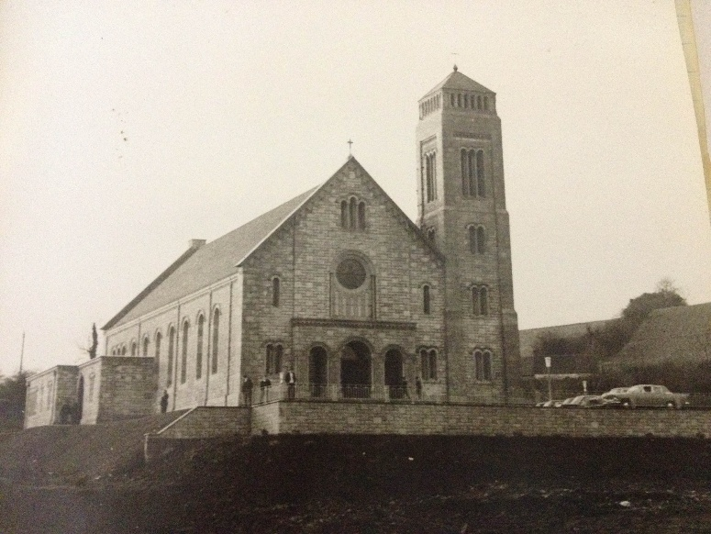

3rd Sunday in Ordinary Time

Fr Michael Sheehan PP 028 9081 2238
Fr Anthony McHugh E CC 028 9751 0237
Email: saintfield@downandconnor.org

Spiritual Exercises: 5 Day Silent Ignatian Retreat for Men - Led by Benedictine monks from St. Joseph Abbey, in France. Starts Thursday 30th April (3pm). Benburb Priory, Co. Tyrone €450 (all meals & single room included). Daily Mass - Ordinary Form (Latin & ad orientem). Discover the strength that only comes when you stop running and let God speak. Book at: https://soutenir.clairval.com/retreat-benburb-priory

Marriage Enrichment Weekend, is scheduled to take place from Friday 20th to Sunday 22nd March 2026 at St. Mary’s Retreat Centre, Knock, Co. Mayo. Marriage Enrichment has, for many years, supported married couples in their Sacrament of Matrimony by offering them a sacred space to deepen their relationship, renew their commitment, and grow together through reflection, prayer, and dialogue. To book visit: www.marriageencounter.ie

North Down Museum Bangor
Saturday 7th February
Enjoy a demonstration of St Brigid Cross Making and using the materials provided make your own cross. For more info.visit https://www.visitardsandnorthdown.com/whats-on/celtic-saints-a-journey-through-time-and-tradition-p948071

Beginning Experience is offering a programme of bereavement support in St Bride’s Hall, Derryvolgie Ave., Belfast on three Saturdays, 31st January 28th February and 28th March. To book call 07519289185 or Marie 07896119669 email belfastbe@yahoo.com

All bookings for Mass, Month Minds, Anniversaries, Baptisms and Weddings are now to be made through the Parish Office or Parish email address at: saintfield@downandconnor.org. Office Hours: Monday & Wednesday11.00am -1.00pm. Please use the Parish Email outside of Office Hours and we will respond as soon as possible.

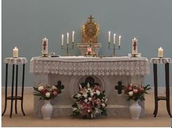

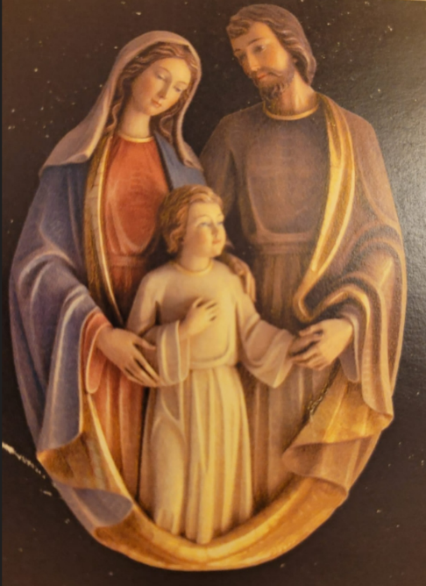

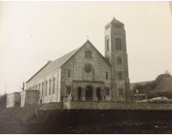

Sunday 25 January - 3rd Sunday of Ordinary Time

https://assets.ctfassets.net/vy3axnuecuwj/b327a24f91248092c4db27084d07442d029b0277e0b773e643e8a298f42bd158/0b9ffef2ab7b5ca63dc4499f3f222408/Children-s_liturgy_pic_A_-_3rd_Sunday_Ordinary_Time.pdf

At today’s Mass, we hear about people who lived in darkness seeing a great light. This is the light that Jesus brings into the world. It is the light of God’s love for each one of us. Jesus asks us to care for one another. By doing this we can help the light of Jesus to shine in the world. What will you do to share the light of God’s love for us all this week?

Our prayer for this week: God of hope, share your light with all your children as we work together to help those among us who are in need. Amen.

Copies of our colouring page and worksheets are available in the church and here is a link to https://thekidsbulletin.com which is also worth reading.

Sunday 1 February - 4th Sunday of Ordinary Time

https://www.scoilmhuireglenties.com/_files/ugd/9347e4_7b9abf4abe264eba914da0e89cde7204.pdf

https://resource-ni.com/wp-content/uploads/2023/01/st.-brigids-feast-day-and-bank-holiday-resources.pdf

At today’s Mass, we hear about how Jesus is baptised by John in the waters of the river Jordan. Water is a very important part of baptism, but it is also really important in our lives for other reasons. We all need water to live. Let’s think this week about all the ways we use water in our lives and about how we can protect our environment by using less water.

Today is also the Feast of St Brigid, one of Ireland’s three patron saints. Why not find out more about Brigid or try making your own St Brigid’s cross?

Our prayer for this week is: St Brigid of Ireland, help us we pray to be kind and loving in our work and play. Amen

Copies of our colouring page and worksheets are available in the church and here is a link to https://thekidsbulletin.com which is also worth reading.

Sunday 8 February - 5th Sunday of Ordinary Time

https://sermons4kids.com/storage/5135/plugged_in_turned_on_bulletin.pdf

Hello children. In the gospel today Jesus tells us that we are light to the world. If we love other people and do what we can to help them, then other people will see how great God’s love is. We will be like the light that shines and is not covered up, so that everyone can see. How will you be like a shining light this week?

Our prayer for this week is: Heavenly Father, thank you for sending Jesus to be the Light of the World. Help us to let his light shine through us so that others will put their faith and trust in him. In Jesus' name we pray. Amen.

Copies of our colouring page and worksheets are available in the church and here is a link to https://thekidsbulletin.com which is also worth reading.

Sunday 15 February - 6th Sunday of Ordinary Time

https://sermons4kids.com/storage/26232/forgiving_and_forgiven_bulletin-pdf.pdf

Hello children. In today’s gospel, Jesus tells us that we must try hard not to get angry with our sisters and brothers or call them names. He also reminds us that, we do argue with them, we should try to make it up with them and become friends again as soon as possible.

We are all part of God’s family. That is one big global family that includes all people wherever they are in the world. All people are our sisters and brothers and God asks us to try to treat them as we want to be treated.

Our prayer for this week is: Loving God, when we do wrong and hurt others help us to be brave and say sorry. Help us to all live in peace together. Amen.

Copies of our colouring page and worksheets are available in the church and here is a link to https://thekidsbulletin.com which is also worth reading.

Sunday 22 February - 1st Sunday of Lent

https://assets.ctfassets.net/vy3axnuecuwj/c1295e538ff64255d44505d2d98e609f86db6cba8a4c62a2c84038bf44f8d813/cb6f8d0a9e687b2970418bb3a0e56bf4/First_Sunday_in_Lent_activity_sheet_2023_v2.pdf

https://sermons4kids.com/storage/26236/temptation_of_christ_bulletin-pdf.pdf

Hello children. In today’s gospel, we hear about how Jesus spent 40 days in the desert and how, at the end of this time when he was tired and hungry, he was tempted with offers of bread, power and glory.

Lent is a time when we try to turn back to God. We say sorry for the things that we have done wrong and we try to make a change to live as God wants us to. This is not always easy, but God’s love is there to give us strength to make better choices, and the people who love us are there to support us too.

This Lent, let’s think about how we can make good choices – just like Jesus did in the desert – even when we find it hard.

Our prayer for this week is: Christ Jesus, give us strength as we try to make the right choices and live as you ask us to. Guide us so that we may also offer support to those who are finding things tough. Amen.

Copies of our colouring page and worksheets are available in the church and here is a link to https://thekidsbulletin.com which is also worth reading.

Sent from my iPad

